Room B
BQ1 Trauma / MVC / Pancreatic Injury
Stem: In the trauma bay, A 35-Year-old female, involved in a head on MVC. ATLS initiated. You do primary and secondary surveys. IV access established, she is talking to you and is complaining of pain primarily in her chest and abdomen.
Vitals: HR of 130, BP 150/90, RR 18 and sating 99% on room air.
She is noted to have a seatbelt sign and. Her chest wall is mildly tender, her abdomen is peritonitic with severe epigastric tenderness.
Medical and Surgical history are unremarkable.
FAST / CXR are negative.

How are you going to manage this patient?
- ATLS
- Trauma panel (Labs are significant for WBC 16.0, Hgb 12.2, CMP is normal, and amylase is 300, lactate 1.0.
- CT scan shows a small amount of free fluid around the left upper quadrant and lesser sac, as well as a Grade 4 splenic laceration.
What is your differential diagnosis?
- Known splenic injury.
- Pancreatic Injury
- Perforated viscus (small bowel or stomach)
After CT scan, her BP trends down to 80/40, HR 140.
- Transfuse blood products (start with 2 units PRBCs)
- Ex.lap
  - Open / Explore
  - Pack 4 quadrants (Blood pressure responded to transfusion)
  - Splenectomy
  - Explore
Splenectomy was uncomplicated, hemostasis achieved, patient is hemodynamically stable.
You notice mild contusion of the pancreatic body, you can’t see obvious duct injury? What would you do?
Place Darin
You place a drain and conclude your operation, patient is closed, no packs left.
On POD 2 you notice the drain is putting > 350 cc , serosang. Your junior resident is asking you if they can obtain labs from the drain output, would you like to order specific labs?
Amylase from drain: > 2 times upper limit of normal
Next day drain is with higher output , what would you like to do?!
- MRCP with secretin stimulation for evaluation of main pancreatic duct (ERCP is an acceptable alternative, but risk of worsening pancreatitis in trauma patient): MRCP negative
- Consider octreotide.
- Repeat CT in 4-6 weeks?
What If persistent drainage , now a fistula? ERCP / Stent
What if when obtained MRCP earlier, it showed main pancreatic duct disruption?! ERCP/ Stent
ERCP attempted, Due to the patient’s anatomy, multiple attempts at pancreatic ductal cannulation were unsuccessful and the procedure was aborted. The patient continues to have high output of the LUQ drain despite being on octreotide How would you manage?

Ex lap for distal pancreatectomy.
- Attachments of spleen will already have been mobilized thus mobilize splenic flexure more if improved visualization needed.
- Open entirety of gastrocolic ligament.
- Mobilize tail of pancreas to confluence of SMV/Splenic vein and transect pancreas.
- Sharp division or division with energy device with oversewing of duct and gland. +/- oversewing .
- Can cover with omentum

BQ2 GIST

Stem: A 70yoF presents to your office with complaints of 4 months of early satiety. She denies any nausea/emesis, constipation, denies hematechezia or hematemesis. Last colonoscopy 5 years ago, normal. She endorses a 10lb weight loss in the same amount of time

PMHx: hyperlipidemia, hypertension

PSHx: inguinal hernia repair 30 years ago

Meds: metoprolol, cholesterol med, baby aspirin

SocHx: social drinker; 20 pack year history smoker, quit 20 years ago

FH: Non-contributory

Vital Signs: BP 142/85 HR 75 99% on room air

PE: well appearing female although thin. Abdomen soft, nontender with palpable left upper abdominal mass. No associated lymphadenopathy

How would you work up this patient?

Work up:

CT abd/pelvis with IV/PO contrast – 7cm heterogenous mass associated with the gastric fundus without evidence of liver or peritoneal metastases or adenopathy

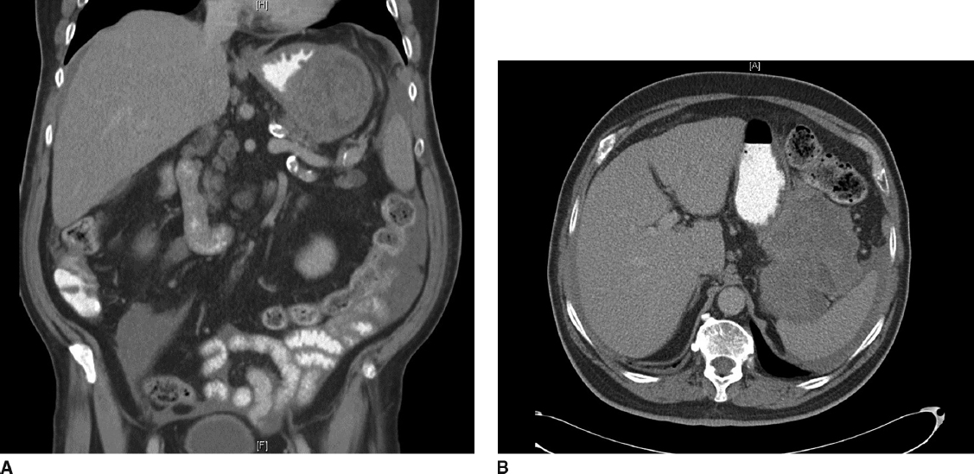

Diagnosis:

Gastrointestinal stromal tumor

What would you like to do next?

EGD (Describe)

Procedural sedation

Place in left lateral decubitus position

Insert scope into mouth under direct visualization

Pass the scope past the cricoarytenoid cartilage into the esophagus

Ensuring direct visualization, pass the scope through the esophagus with continuous insufflation in order to visualize the entire esophagus

Visualize the gastroesophageal junction and pass into the stomach

EGD demonstrates large submucosal mass without any ulceration.

If examinee asks for :
- biopsy: no pathologic abnormality
- EUS: large heterogenous mass contiguous with gastric wall without perigastric lymphadenopathy
- FNA: spindle cells, immunohistochemistry not performed. (FNA not necessary unless concerned for metastatic spread, unresectable or neoadjuvant therapy is planned)
- MRI or PET – not available

How would you treat this patient?

Resectable GIST. No neoadjuvant therapy is necessary

Describe operative approach:

Can perform laparoscopically or open.
- If laparoscopic:
  - need to describe position and port placement: lithotomy or supine position
  - 12mm port to the left of the umbilicus.
  - 4 additional ports – right of umbilicus, right costal margin, left costal margin and liver retractor

- Open – supine position, upper midline celiotomy
  - Examine the abdomen for metastases
  - Resect the GIST with 1cm gross margin utilizing staple device, ensuring not to narrow the gastroesophageal junction.
  - Should use endoscopy or bougie to ensure against narrowing of stomach or GE junction.
  - Should perform leak test
  - Ensure not to disrupt the pseudocapsule and cause spillage of tumor

Pathology returns as 7cm gastrointestinal stromal tumor with mitotic rate >50/HPF, Any other recommendations for this patient’s care?

Imatinib for at least 3 years

H&P as well as CT scan every 6months-1 year for at least 10 years

BQ3 BURN
Stem: A 47 y/o male is brought to the ED by EMS after being evacuated from a bedroom fire, started while he was smoking in his bed.
Upon evaluation he is awake and conversive but appears confused.
He is noted to have 60% TBSA burns to his upper torso, sparing only his lower extremities. His nasal hair is singed and he has a productive cough with a hoarse voice.
HR- 115, RR- 30, BP – 95/50, Temp – 37C, SpO2-100%.

Additional Workup or Studies:
CMP, CBC, carboxyhemoglobin, lactate

What are you concerned about?!:
- Airway compromise with an upper airway inhalation injury
- Development of decreased pulmonary compliance with circumferential burns to the torso
- Carbon monoxide poisoning
- Hypothermia
- ARDS/multisystem organ failure
- Compartment syndrome in extremities or abdomen

What would you like to do now?
- Intubate – 100% FiO2
- Serial carboxyhemoglobin levels
- Establish adequate IV access and initiate fluid resuscitation using parkland formula:
2-4 ml/kg/%TBSA burn using LR. First ½ within 8 hours of burn.
Second ½ in the next 16 hours
- Place a foley to monitor resuscitation. Goal 30 – 50 cc/hr

Scenario: Patient is 100 kg, received 60% TBSA burn. He arrives four hours after his burn and has received a total of four liters of crystalloid. How would you manage his fluids at this point

Parkland: 100 kg * 60% *2ml/kg = 12L in first 24 hours, 6L in first 8 hours. Patient has already received 4L 🡪 500 cc/hr for the remainder of the first 8 hours.

Scenario: Patient has been transported to the ICU and is being mechanically ventilated. You get a call from respiratory therapy that his peak airway pressures have increased to 35. What are you concerned about?

- Abdominal compartment syndrome.
- Restrictive physiology due to thoracic eschars)

What would you do?
- check bladder pressure
- Perform escharotomy of thorax

Describe
- Escharotomy of the thorax
- Vertical incision bilaterally between mid-clavicular line and mid axillary line.
- Connected by transverse incision x 2
- Bronchoscopy to evaluate degree of inhalational injury for prognostication and treat potential mucus plugging

What is the ARDS/vent management?
- Low tidal volume (4-6 ml/kg)
- Peak pressures <30
- Permissive hypercapnia (ph >7.2)
- Increase PEEP
- Consider proning.

Scenario 3: Patient is going to require skin grafting. Now he is on tube feeds. What is the nutrition/caloric need?

25 kcal/kg +40 kcal/%TBSA, protein 1.5 g/kg +3 g/%TBSA.

Scenario 4: 65 y/o male cement worker presents after cement has spilled through his shirt on his chest and he continued to work in the sun for the next 6 hours but noticed a terrible burning sensation over the area at the end of his shift. HR 90, BP 120/80, RR 15, Temp 37.2, what would you do?

- Call Poison control to obtain further recommendations and verify acid vs alkali
- Determine alkali burn – liquefactive necrosis.
- Begin burn resuscitation.
- Large volume lavage with water until pH <8, may require operative debridement.
- May require skin graft once wound has stabilized.

